# problem Statement

* There is an ‘Employee’ service which provides endpoints to create, update and get employees details.

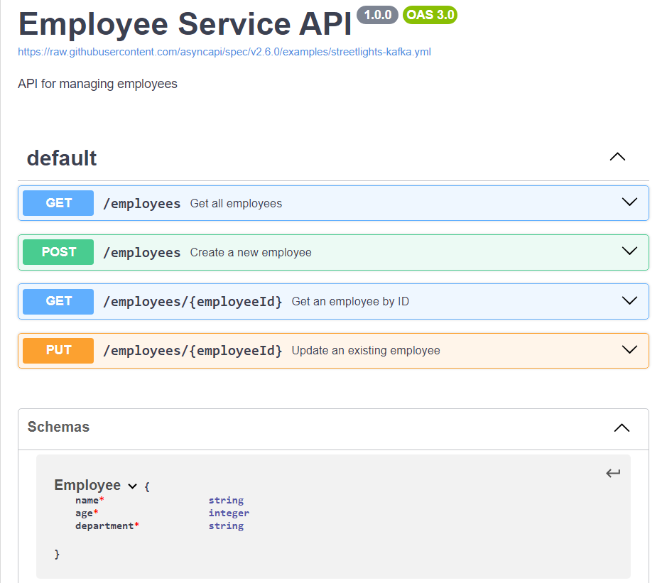



* There is a ‘Dashboard’ which is exposed to HRs that internally calls the ‘Employee’ service APIs, lets call this dashboard as consumer of employee service.
* A scalable test approach needs to be created that:
  + Creates a contract of both the services (dashboard and employee).
    - **Consumer contract** for Dashboard service and **Provider contract** for Employee service.
    - Note: Contract represents A document that contains the expected mocked Http response on a mocked Http request.
    - Use pact-python (Python library) to generate the contracts.
  + Write test cases.
    - To allow Consumer contract to be created only if Provider contract exists otherwise fail.
    - Consumer contract should always be the subset of the Provider contract.
    - As soon as there is change in APIs of provider, contract needs to be updated and updated contract needs to be checked that it is not breaking any Consumer contract.

